Implementation of a 3 bit up and down counter using FPGA’s source clock and Clock Divider

LAB # 07



Spring 2024
CSE-308L Digital System Design Lab

Submitted by: Ali Asghar
Registration No.: 21PWCSE2059
Class Section: C

“On my honor, as student of University of Engineering and Technology, I have neither given nor received unauthorized assistance on this academic work.”

Submitted to:
Dr. Asif Ali Khan

Date:
28th April 2024

Department of Computer Systems Engineering
University of Engineering and Technology, Peshawar
Objectives:
This lab will enable students to:
- To become familiarized with behavior level modeling
- To be able to implement sequential circuits using Verilog
- To implement a 3 Bit Up and Down Counter on Spartan 6 FPGA starter kit.

Software used:
- Xilinx ISE

Commonly Used Modules:
The following modules are used commonly in each task. Hence, to avoid redundancy, I have pasted their working and code screenshots in this section only.

Clock Divider:
A clock divider is a circuit that takes an input clock signal and generates an output clock signal with a lower frequency. These circuits are commonly used in digital systems for various purposes, such as generating slower clock domains, creating timing signals, or driving sequential logic elements.
Code:
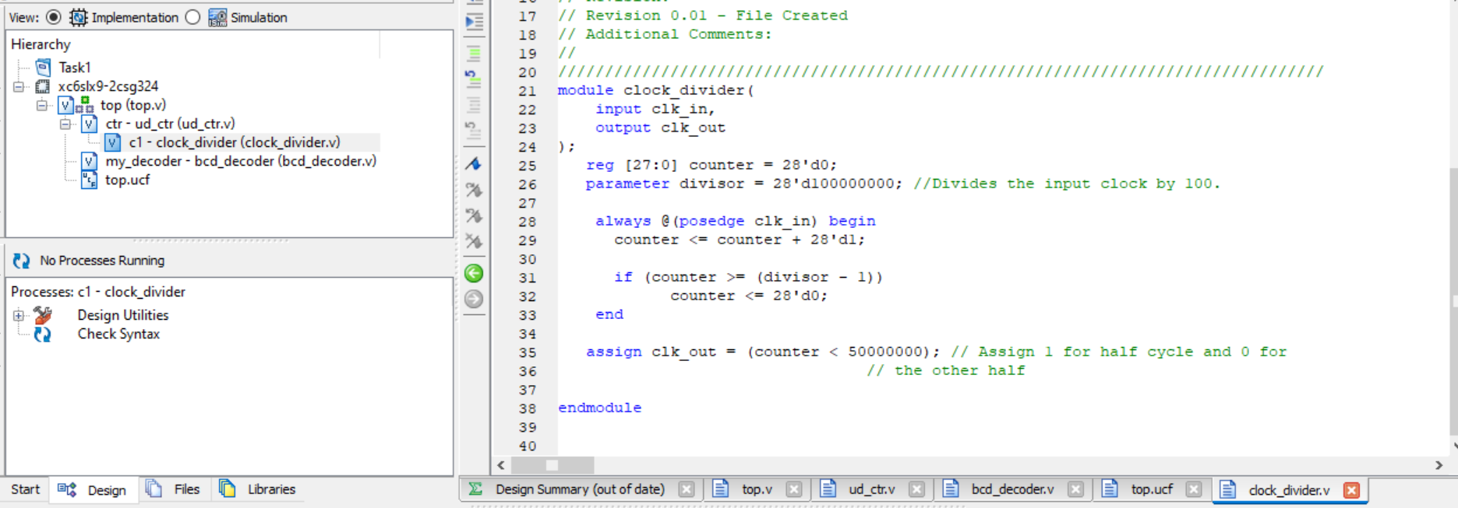
Figure 0.1: Clock Divider Code

BCD Decoder:
BCD decoder module takes a 4-bit BCD input and produces an 11-bit output based on the specified mapping.

Code:
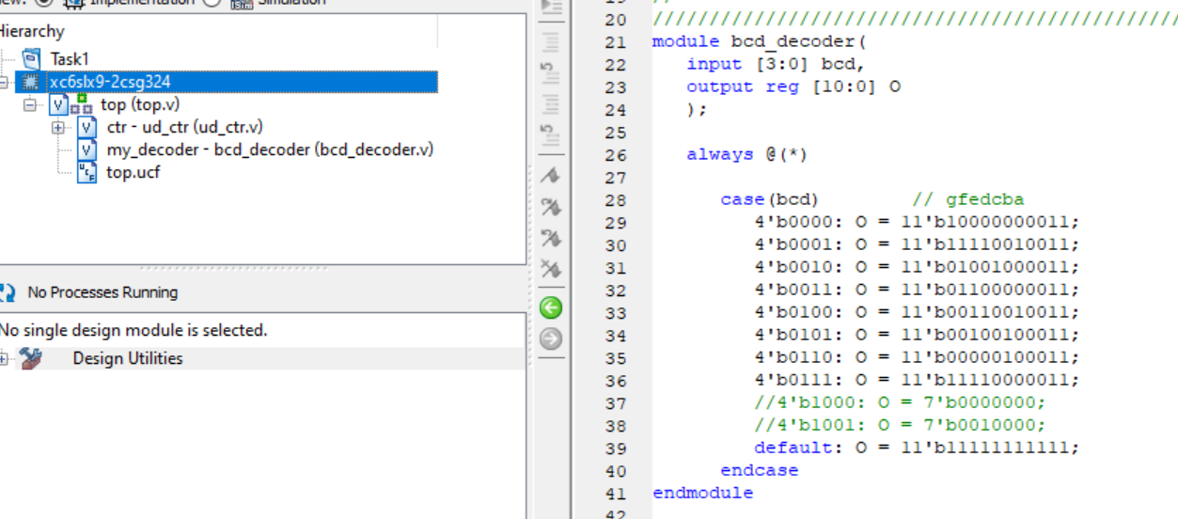
Figure 0.2: BCD Decoder Code

Task 1:
Implement 3-bit Up Counter using FPGA’s clock source and clock divider.

Code:
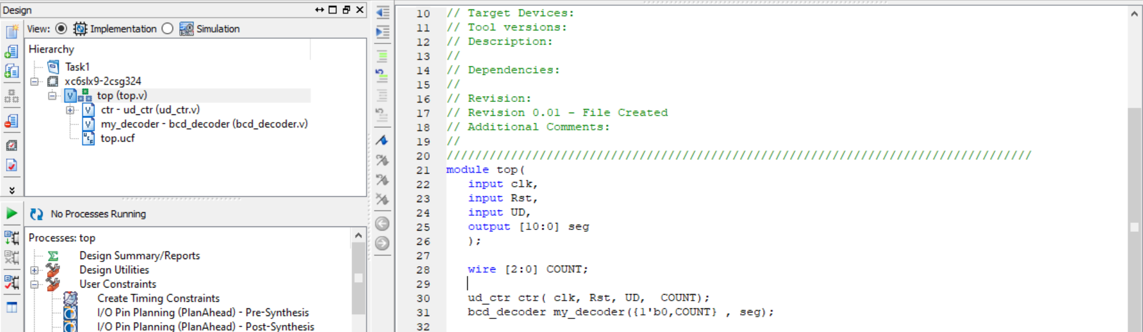
Figure 1.1 top module

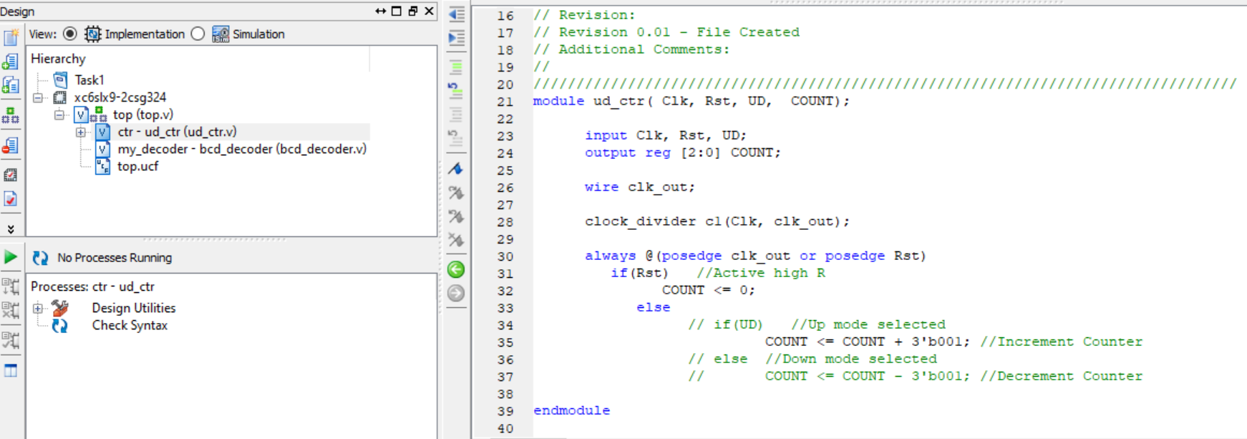
Figure 1.2: Up Counter Code

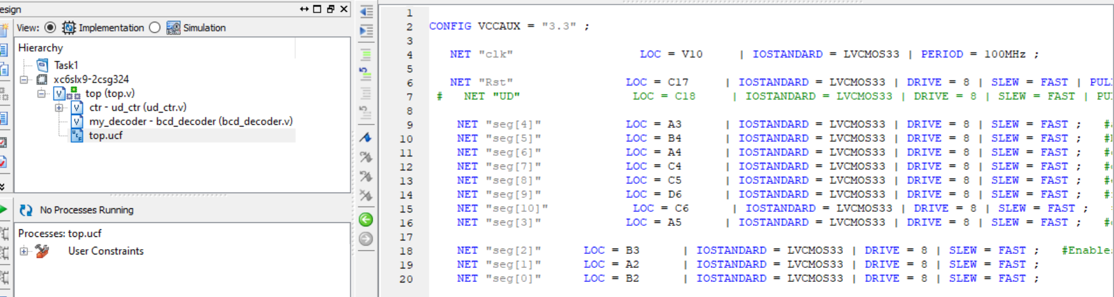
Figure 1.3: UCF File for Up Counter
Output:
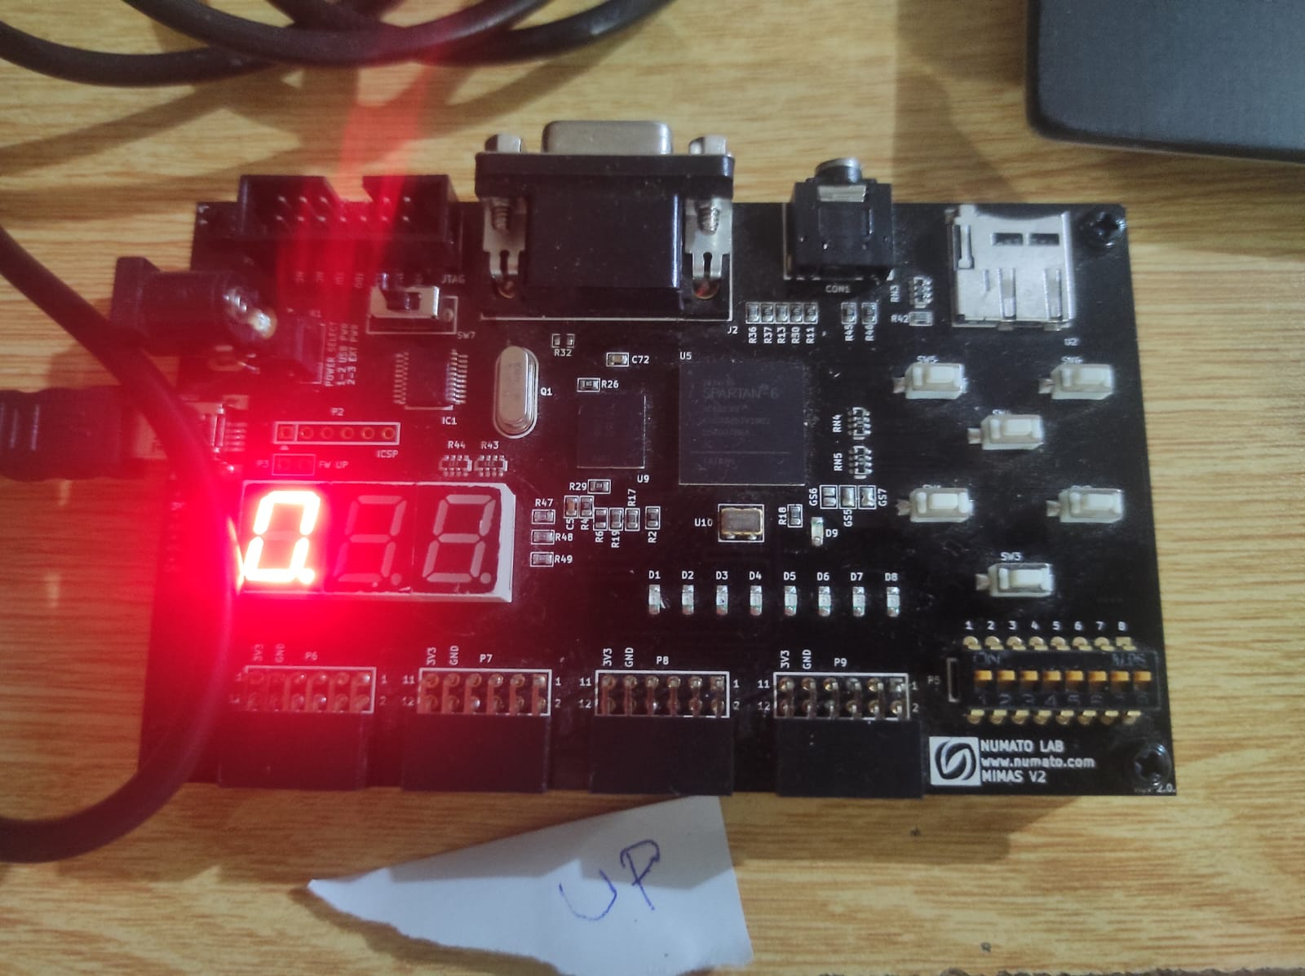
Figure 1.4: Up Counter Implementation on Spartan6 FPGA Board

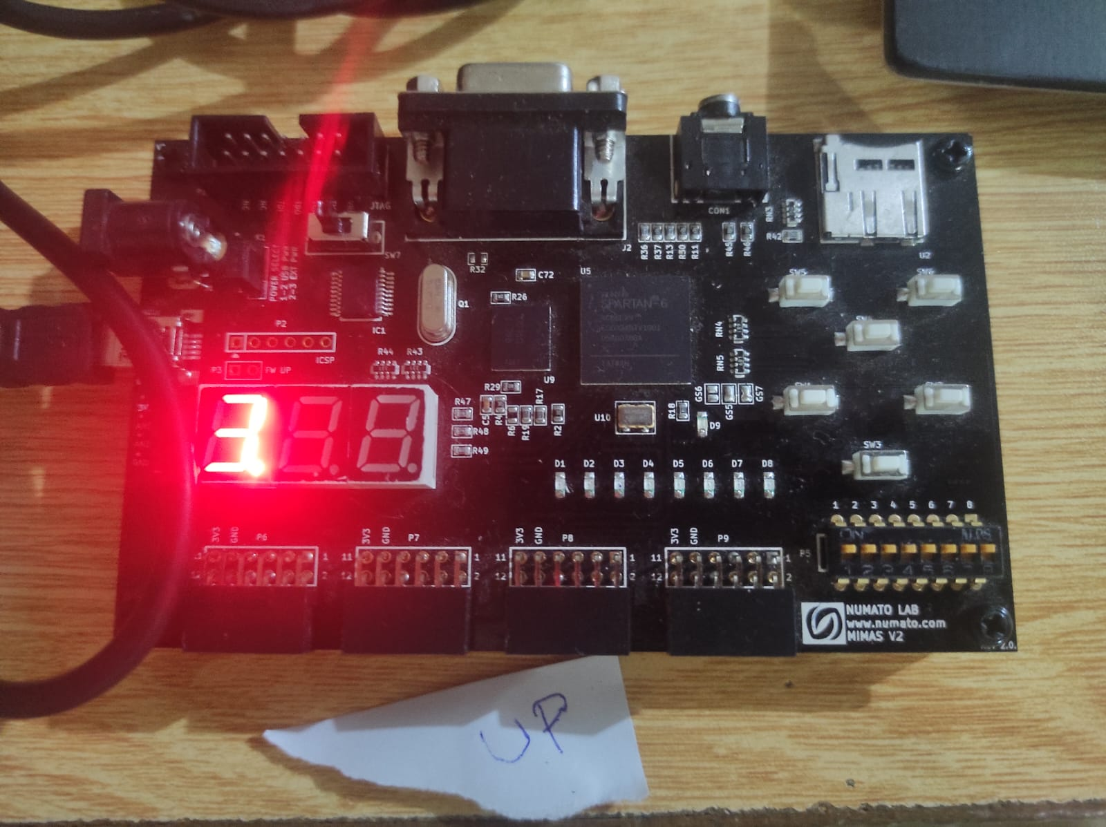
Figure 1.5: Up Counter Implementation on Spartan6 FPGA Board
Task 2:
Implement 3-bit Down Counter using FPGA’s clock source and clock divider.

Code:

Figure 2.1 top module

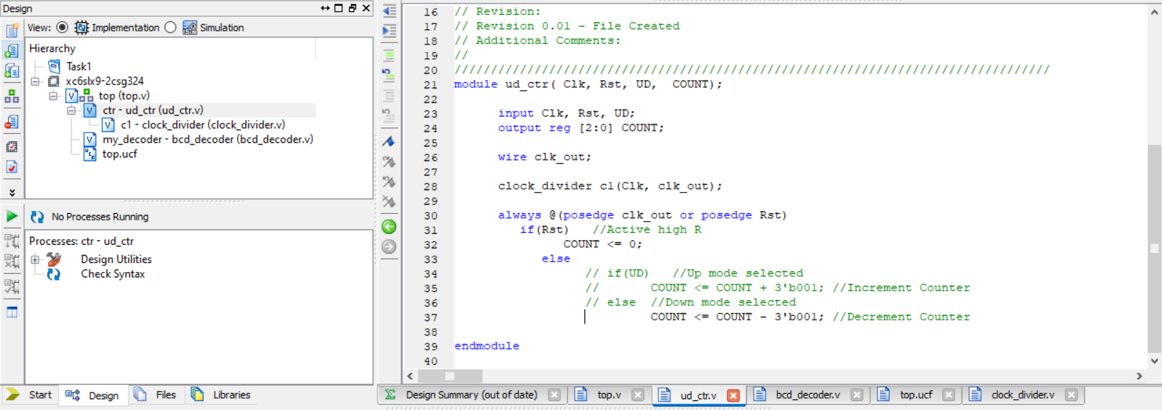
Figure 2.3: Down Counter Code

Figure 2.3: UCF File for Down Counter

Output:
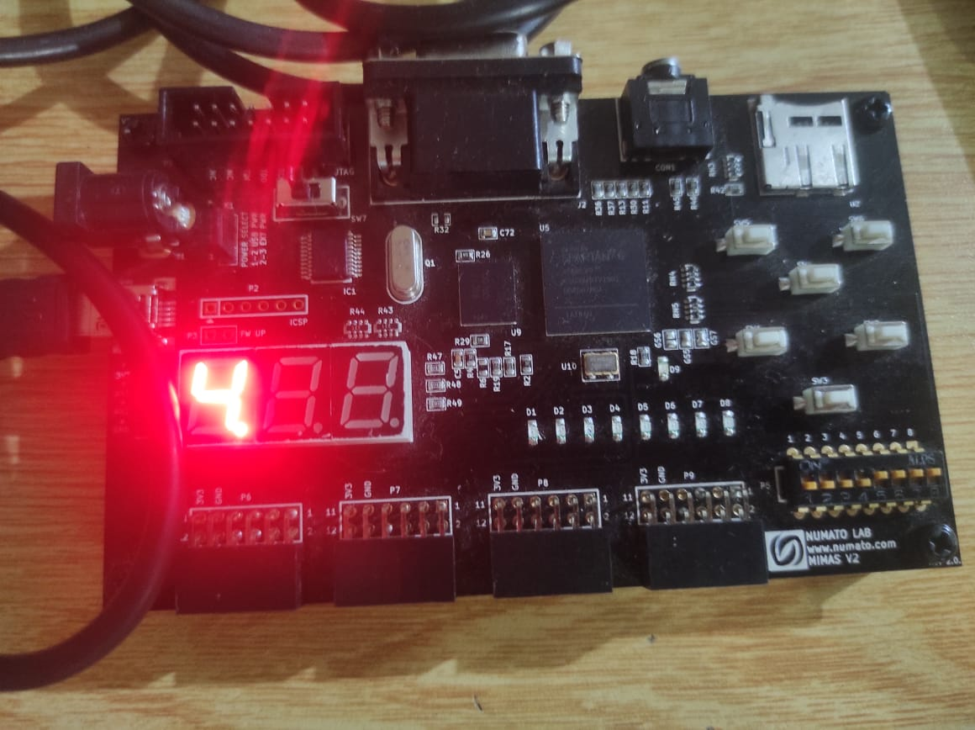
Figure 2.4: Down Counter Implementation on Spartan6 FPGA Board

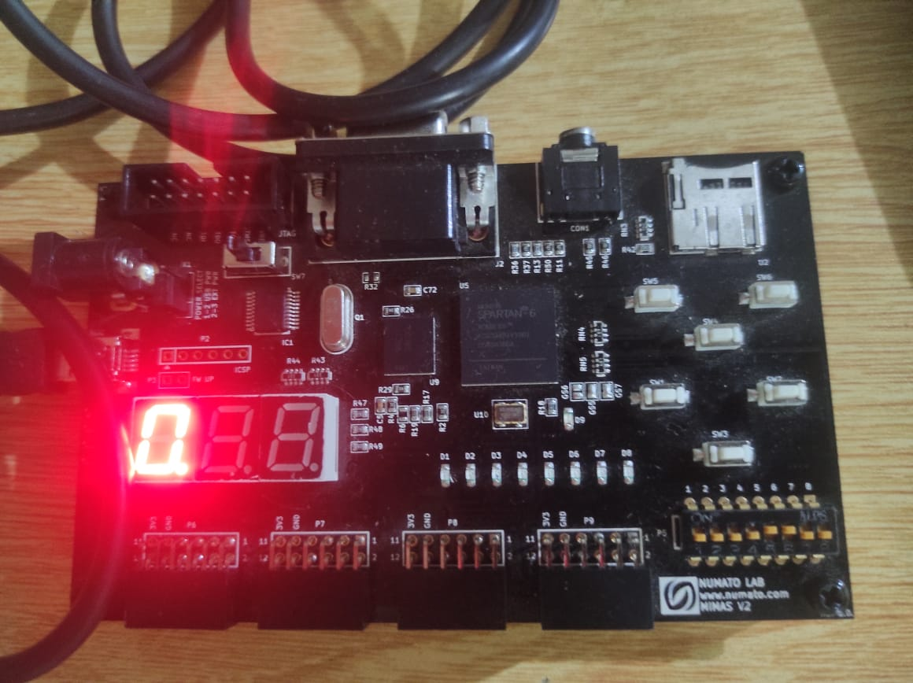
Figure 2.5: Down Counter Implementation on Spartan6 FPGA Board
Task 3:
Implement 3-bit Up and Down Counter using RST if the RST is high it should Count Up if it is low it should Count Down and display the count in the seven segment display.

Code:
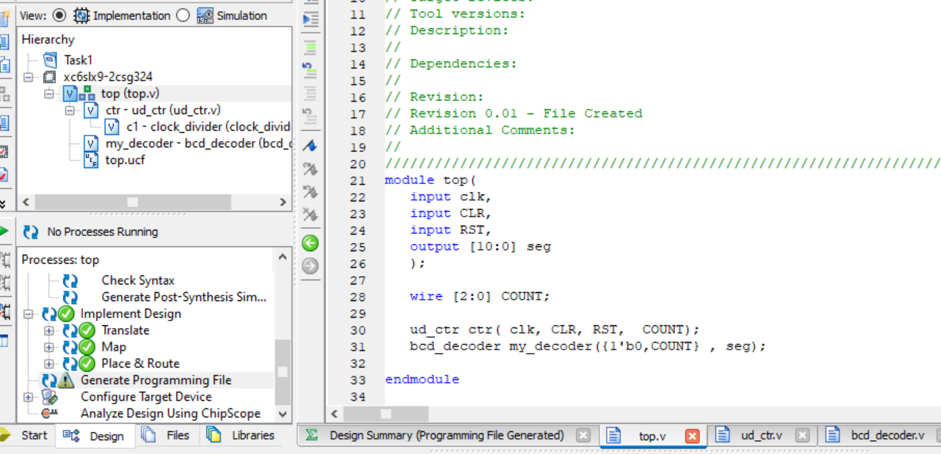
Figure 3.1 top module

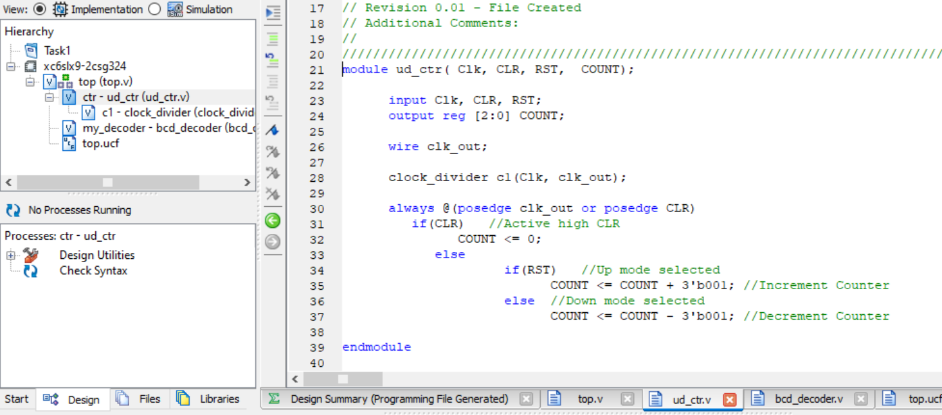
Figure 3.4: Up-Down Counter Code

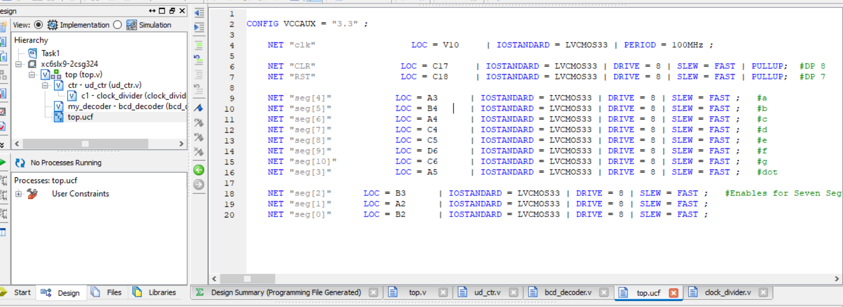
Figure 3.3: UCF File for Down Counter

Output:


Figure 3.4: Up-Down Counter Implementation on Spartan6 FPGA Board


Figure 3.5: Up-Down Counter Implementation on Spartan6 FPGA Board


Figure 3.6: Up-Down Counter Implementation on Spartan6 FPGA Board

